

Business Proposal

WEDE

502

0

P

ART

1

2025

ST10470860

SFISUK'THULA GOD'SRICH NGCEBO MAGAGULA

[COMPANY NAME] | [Company address]

### Table of Contents

DECLARATION 2

Organisation Overview 4

Website Goals and Objectives 6

References 9

## DECLARATION

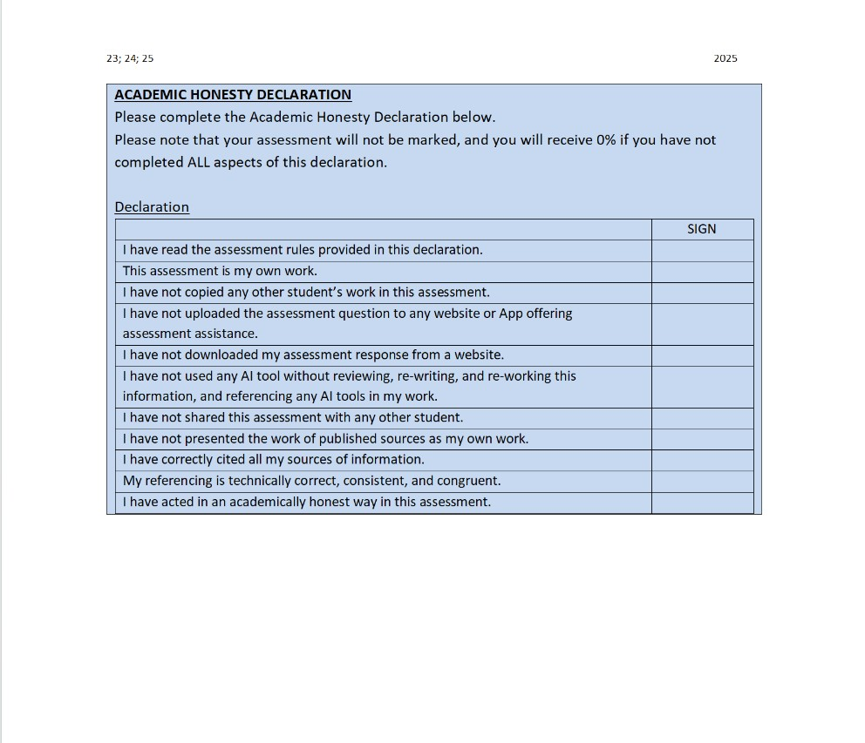

(2018, p. Rehab Clothing Rsa)

**Name:** Rehab Clothing

**Industry:** Clothing/ Fashion and apparel

**Established:** 2017

**Founder:** Rehab Sfisosethu Oratile Magagula.

**Mission Statement:** Rehab clothing aims to shift the youth’s perspective from violence and crime by making them focus on street wear, giving them the ability to express their creativity.Rehab clothing not only focuses on the youth but also aims to shift the game of street wear by offering the finest texture of materials, Rehab clothing aims to take over or be one amongst the biggest black owned clothing brands.

# Organisation Overview

**Name:** Rehab Clothing

**Industry:** Clothing/ Fashion and apparel

**Established:** 2017

**Founder:** Rehab Sfisosethu Oratile Magagula.

**Mission Statement:** Rehab clothing aims to shift the youth’s perspective from violence and crime by making them focus on street wear, giving them the ability to express their creativity. Rehab clothing not only focuses on the youth but also aims to shift the game of street wear by offering the finest texture of materials, Rehab clothing aims to take over or be one amongst the biggest black owned clothing brands.

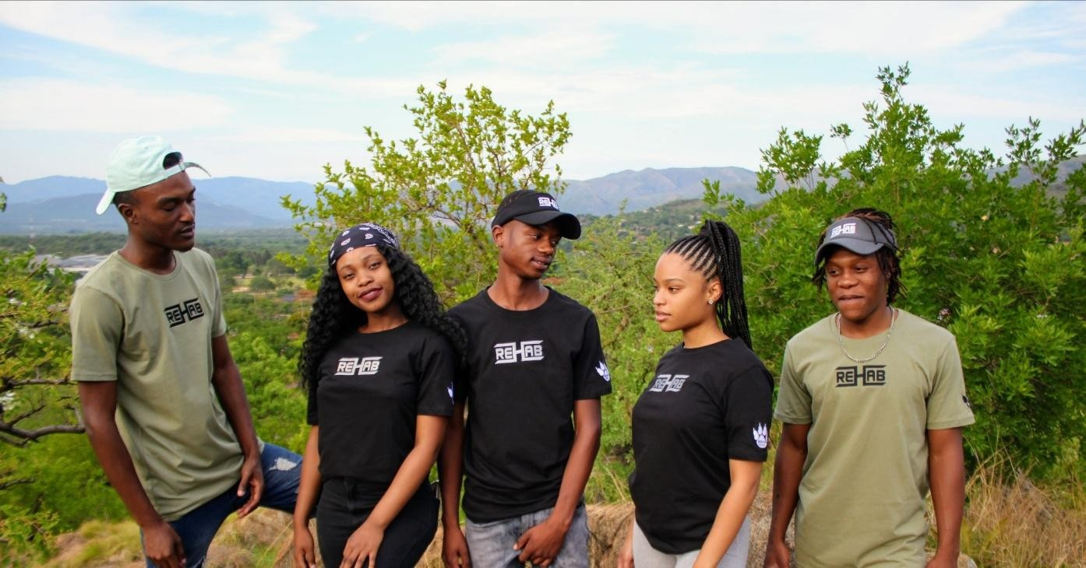

(Rsa, 2018)

**Background:** Founded in Mbombela, South Africa, in a small town called Barberton. Rehab Clothing has grown little by little from a local fashion startup into a recognizable name in streetwear culture. The brand is known for its edgy designs, multiple colours, and strong relationship with the local community. With a growing support system, Rehab Clothing seeks to do more than contact market but also aim for the digital market through a user-friendly website. (reporter, 2022) (Dabata, 2025)

# Website Goals and Objectives

**Primary Goals:**

* Showcase the brand’s identity and product catalogue.
* Enable seamless online shopping and secure transactions.
* Build a loyal fan base through content and interaction.

**Key Objectives:**

* Display the variety of clothing products with high definition and product description.
* Merge e-commerce functionality with inventory management.
* Offer newsletter sign-ups, promotions, and exclusive member content.
* Interact with customers via social media and customer support.

(Winter, 2025) (Anon., 2025)

|  |  |  |
| --- | --- | --- |
| **Features** | **Description** | **Purpose** |
| **Responsive Design** | Optimized for mobile and desktop | Ensures accessibility across devices |
| **E-commerce**  **Platform** | Shopify or  WooCommerce | Enables secure shopping and checkout |
| **Product Catalogue** | Filterable by category, size, and style | Improves user experience and navigation |
| **Lookbook Section** | Editorial-style photo gallery | Highlights brand identity and seasonal drops |
| **Blog/News** | Fashion tips, behindthe-scenes, founder stories | Builds brand loyalty and SEO |
| **Social Media Integration** | Instagram feed, TikTok links | Drives engagement and  traffic |
| **Customer Reviews** | Ratings and feedback | Builds trust and credibility |
| **Newsletter Signup** | Email capture for promotions | Grows mailing list and repeat customers |
| **Features** | **Description** | **Purpose** |
| **Accessibility Features** | Alt text, readable fonts, contrast options | Ensures  inclusivity for all users |

(Patel, 2025) (Hendry, 2025)

**WEBSITE IMPLEMENTATION ADDENDUM (Update Based on HTML Code)**

This section summarizes the current implementation status and specific details of the website as confirmed by the front-end HTML code, without altering the original proposal text.

**I. Confirmation of Key Objectives**

The structure of the website front-end confirms the successful implementation of the following core objectives and features:

* **Product Catalogue Display:** Dedicated sections for **"Featured Products"** and **"New Arrivals"** immediately showcase the core product offering, which currently includes various **T-shirts and Cropped Sweaters/Outerwear**. Each product listing includes an image, brand name, price (in **Rands**), a static star rating system (Customer Reviews UI), and an **Add to Cart** action button.
* **Content and Interaction:**
  + A dedicated **Blog** section is implemented with content focused on streetwear trends and styling tips.
  + The **Newsletter Signup** feature is implemented in the footer/contact section to capture customer emails.
  + **Social Media Integration** is robustly implemented with icons/links for **Facebook, Twitter, Instagram, Pinterest, and YouTube** in the footer.
  + A **24/7 Service** feature is highlighted, confirming a commitment to round-the-clock customer support.

**II. Implementation Specifics and Pricing Strategy**

The HTML code provides the following specific details regarding the business operations and digital presence:

**Pricing and Promotions:**

* **Currency & Price Range:** All products are priced in **Rands (R)**. T-shirts are typically **R150 - R200**, and Sweaters/Outerwear are **R300 - R350**.
* **Promotional Mechanics:** The site actively promotes sales with specific offers:
  + Free delivery on items above **R1000**.
  + Banners announcing sales like **"Up to 40% Off"** and **"Buy 3 for the price of 2."**

**Geographic Presence:**

* The brand's origin is maintained as **Barberton, Mpumalanga**.
* The footer/contact details establish a current base of operations/retail presence at the **Canal Walk Shopping Centre, Cape Town**, confirming a key location in a major South African commercial hub.

**Technical & Future Planning:**

* The footer indicates support for major payment gateways (**Visa, Maestro, MasterCard**).
* The inclusion of placeholders for **App Store** and **Google Play** suggests that development for a dedicated mobile application is a planned future integration.
* The site confirms **"nationwide delivery"** is offered.

**III. Remaining Dependencies**

While the foundational front-end is complete, the proposal’s remaining objectives are dependent on the back-end infrastructure:

* **E-commerce Integration:** The current shopping functionality (Cart, Checkout) is static. The site requires final integration with a suitable e-commerce platform (like Shopify or WooCommerce, as originally proposed) to enable **secure transactions** and **live inventory management**.
* **Filtering & Sorting:** The user interface for filtering the product catalogue by size, category, or style is not yet visible in the front-end structure.

# References

Anon., 2018. *X.* [Online]

Available at: https://pbs.twimg.com/profile_images/1020426762608685056/YUD6rIV4_400x400.jpg [Accessed 04 August 2025].

Anon., 2025. *Big Commerce.* [Online]

Available at: https://www.bigcommerce.com/articles/ecommerce/how-to-start-an-online-clothingstore/

[Accessed 04 August 2025].

Dabata, M., 2025. *Forbes africa.* [Online]

Available at: https://www.forbesafrica.com/entertainment/2025/05/06/a-snapshot-of-southafrican-fashion-from-the-runway-to-the-future/ [Accessed 04 August 2025].

Hendry, S. L., 2025. *W3C.* [Online]

Available at: https://www.w3.org/WAI/standards-guidelines/wcag/ [Accessed 04 August 2025].

Patel, N., 2025. *NeilPatel.* [Online]

Available at: https://neilpatel.com/blog/how-to-create-an-ecommerce-website/ [Accessed 04 August 2025].

reporter, i., 2022. *Glamour.* [Online]

Available at: https://www.glamour.co.za/fashion/these-are-the-emerging-designers-selected-forsa-fashion-weeks-new-talent-search-finale-556cdc80-905b-4160-8aeb-e8127f054774 [Accessed 04 August 2025].

Rsa, R. C., 2018. *x.* [Online]

Available at: https://pbs.twimg.com/media/DuCQncTX4AA8tli?format=jpg&name=4096x4096 [Accessed 04 August 2025].

Winter, D., 2025. *Shopify.* [Online]

Available at: https://www.shopify.com/blog/206934729-how-to-start-a-clothing-line [Accessed 04 August 2025].